Postman
# Source: Chatgpt (GPT-4-turbo) at [6/24/2025]
Postman is a powerful and popular API development and testing platform that helps developers and teams design, test, document, and monitor APIs easily through an intuitive graphical interface.

🧰 What Can You Do with Postman?
# Source: Chatgpt (GPT-4-turbo) at [6/24/2025]
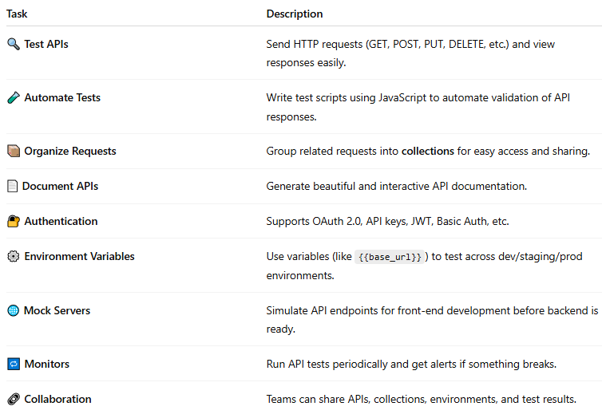

Task | Description
🔍 Test APIs | Send HTTP requests (GET, POST, PUT, DELETE, etc.) and view responses easily.
🧪 Automate Tests | Write test scripts using JavaScript to automate validation of API responses.
📦 Organize Requests | Group related requests into collections for easy access and sharing.
📄 Document APIs | Generate beautiful and interactive API documentation.
🔐 Authentication | Supports OAuth 2.0, API keys, JWT, Basic Auth, etc.
⚙️ Environment Variables | Use variables (like {{base_url}}) to test across dev/staging/prod environments.
🌐 Mock Servers | Simulate API endpoints for front-end development before backend is ready.
🔁 Monitors | Run API tests periodically and get alerts if something breaks.
🔗 Collaboration | Teams can share APIs, collections, environments, and test results.

🖼️ Interface Overview
# Source: Chatgpt (GPT-4-turbo) at [6/24/2025]
- Request Builder: Compose HTTP requests and see live responses.
- Collections: Save groups of requests and share them.
- Environments: Manage dynamic variables (like tokens or URLs).
- Console: Debug with logs (similar to a browser console).
- Tests Tab: Write JavaScript to assert API behavior.

🛠️ Example: Simple GET Request
# Source: Chatgpt (GPT-4-turbo) at [6/24/2025]
- Open Postman.
- Select GET and enter URL: https://jsonplaceholder.typicode.com/posts/1
- Click Send

See response JSON:
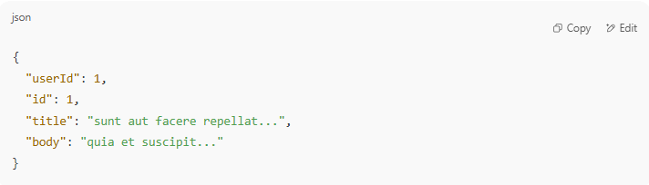
{
"userId": 1,
"id": 1,
"title": "sunt aut facere repellat...",
"body": "quia et suscipit..."
}

🔒 Authentication Support
# Source: Chatgpt (GPT-4-turbo) at [6/24/2025]
Postman supports:
- API Key
- Basic Auth
- Bearer Token
- OAuth 1.0 & 2.0
- NTLM, Digest Auth

🆚 Postman vs CURL
# Source: Chatgpt (GPT-4-turbo) at [6/24/2025]
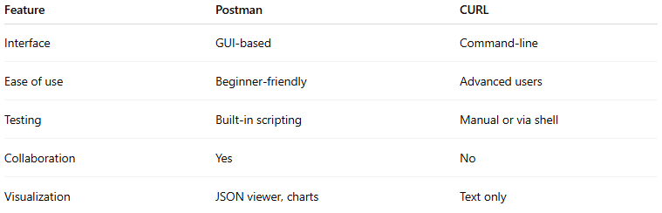

Feature | Postman | CURL
Interface | GUI-based | Command-line
Ease of use | Beginner-friendly | Advanced users
Testing | Built-in scripting | Manual or via shell
Collaboration | Yes | No
Visualization | JSON viewer, charts | Text only

Download Postman
# Source: Chatgpt (GPT-4-turbo) at [6/24/2025]

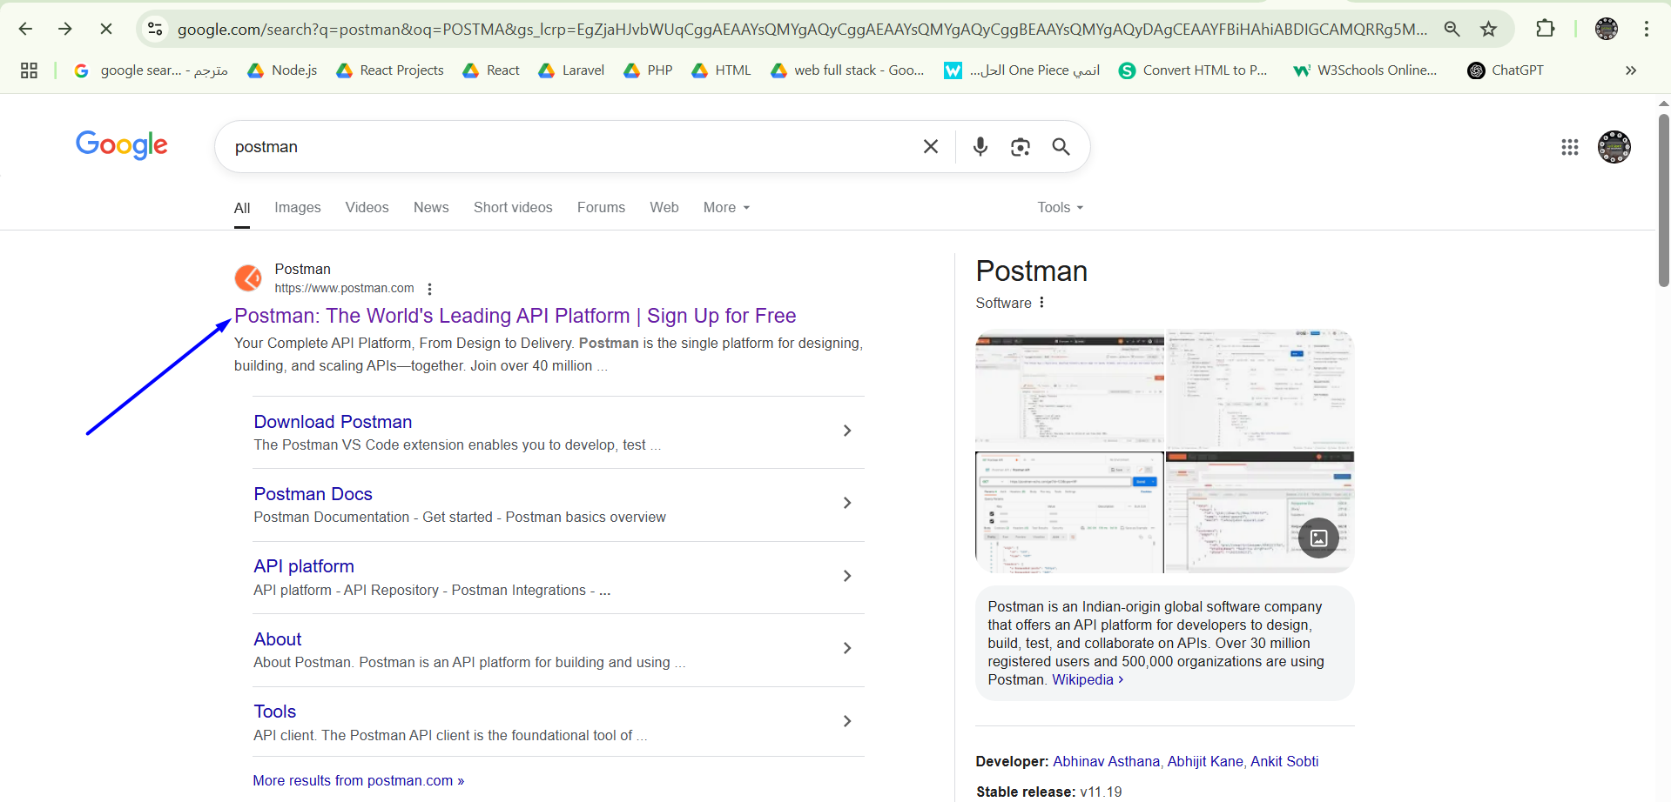
https://www.postman.com/
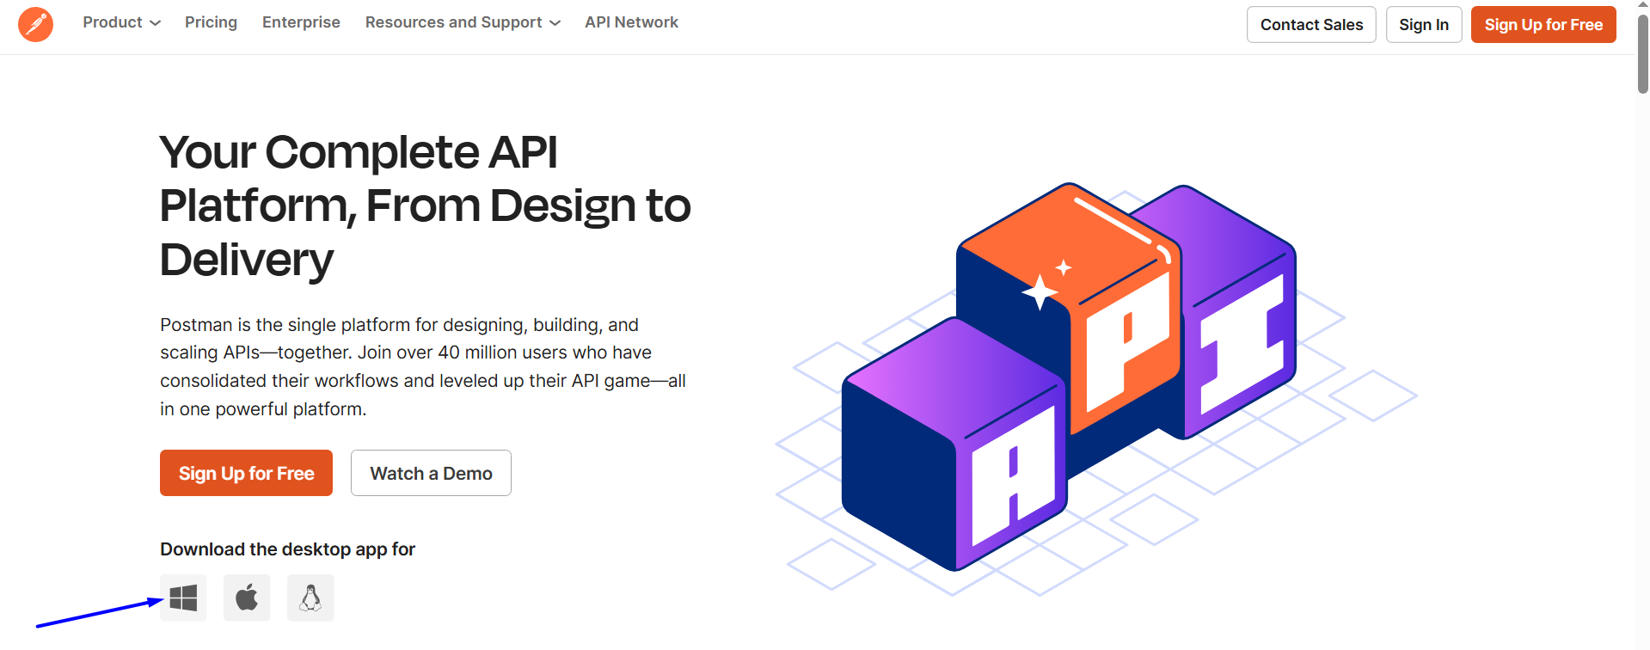

https://www.postman.com/downloads/
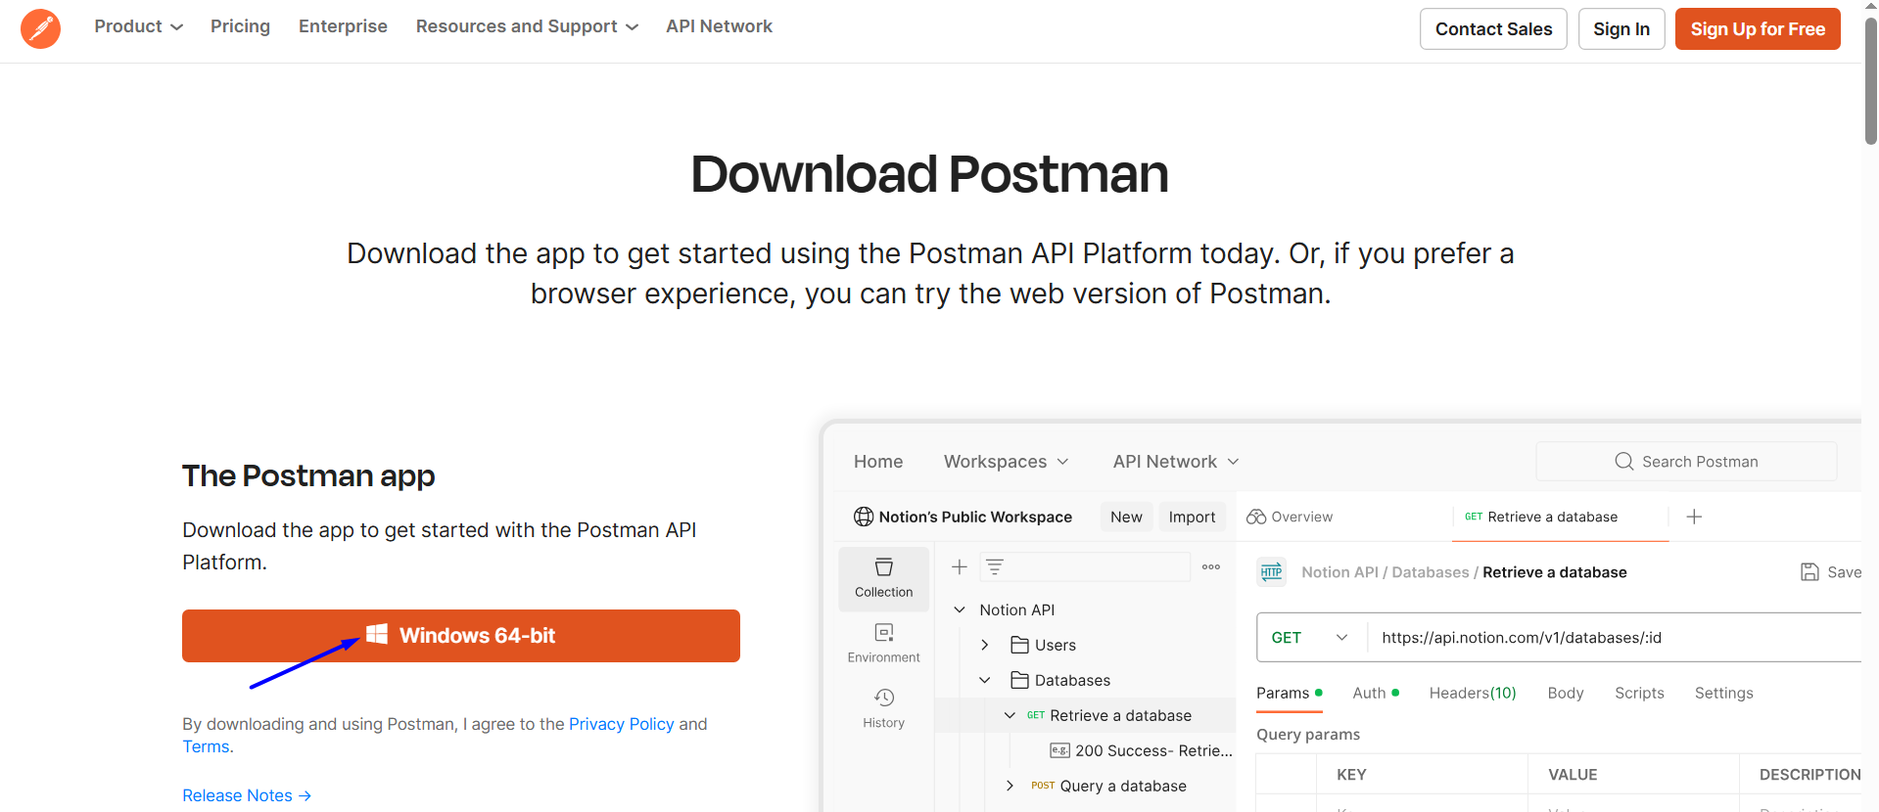

Install Postman
# Source: Windows ScreenShots at [6/24/2025]
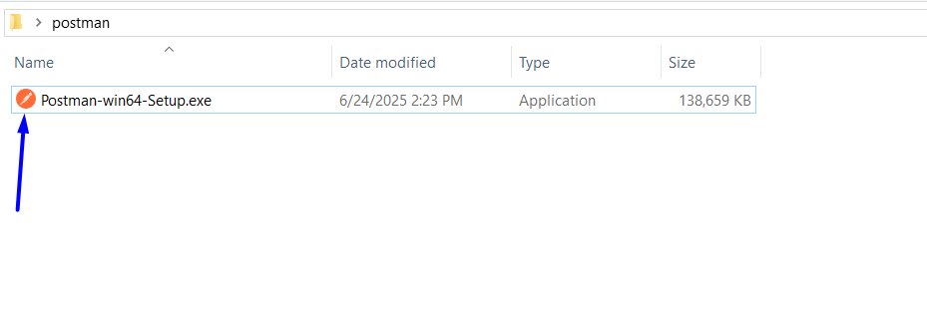

Run Postman
# Source: Windows ScreenShots at [6/24/2025]
